Report
SkillArc – Educational LMS App
Assignment management
1. Introduction
The Assignment Portal is a centralized web-based academic management system designed to streamline the processes of assignment distribution, submission, evaluation, quiz management, and coding-based assessments within an educational institution. It serves as an integrated digital platform that connects students and faculty through structured workflows and clearly defined responsibilities.
The primary function of the portal is to provide a transparent, organized, and efficient academic environment where students can access assignments, submit work, attempt quizzes, and complete coding tasks, while faculty members can create assessments, review submissions, assign grades, and monitor performance. By consolidating these functionalities into a single system, the portal eliminates fragmented processes and reduces reliance on multiple external tools.
The design emphasizes clarity, role-based access control, responsiveness, and usability. It ensures that each user—student or faculty—interacts with a tailored interface aligned with their responsibilities. Through structured navigation and a unified evaluation engine, the portal enhances academic accountability, reduces administrative overhead, and promotes an efficient learning ecosystem.

2. Objectives
The Assignment Portal is developed with the following key objectives:
- To establish a centralized and structured platform for managing assignments, quizzes, and coding assessments within a unified system.
- To enhance transparency and efficiency in submission, evaluation, and grading processes for both students and faculty.
- To provide a responsive, accessible, and user-friendly interface that supports seamless academic interaction across devices.
These objectives guide the overall system design and ensure that the portal remains focused on functionality, clarity, and academic effectiveness.

3. Architecture
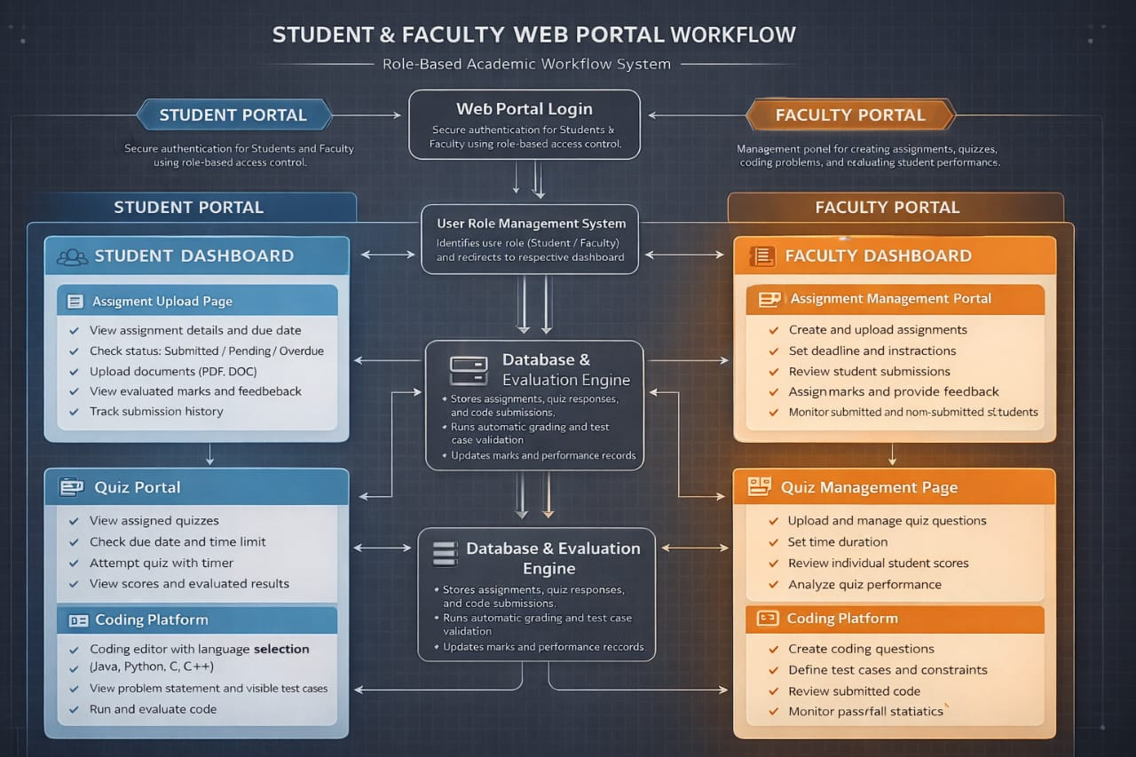

The architecture of the Assignment Portal is organized into distinct yet interconnected blocks, each responsible for a specific function within the academic workflow. The system begins with a centralized login and role management layer, which directs users to either the Student Portal or the Faculty Portal. All modules interact with a unified Database and Evaluation Engine that ensures consistency and integrity of data.
Example
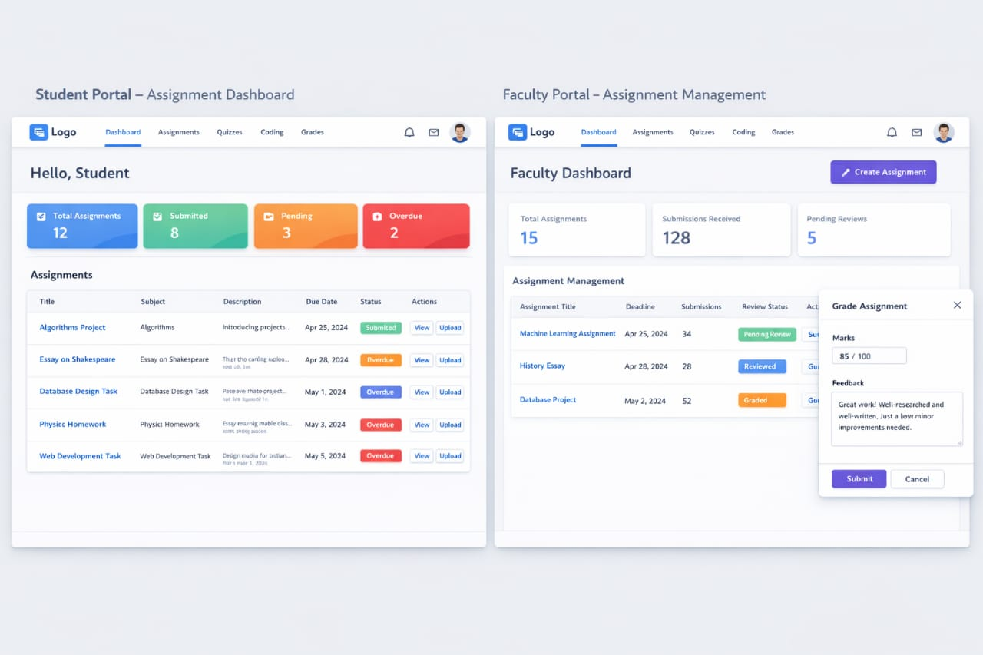
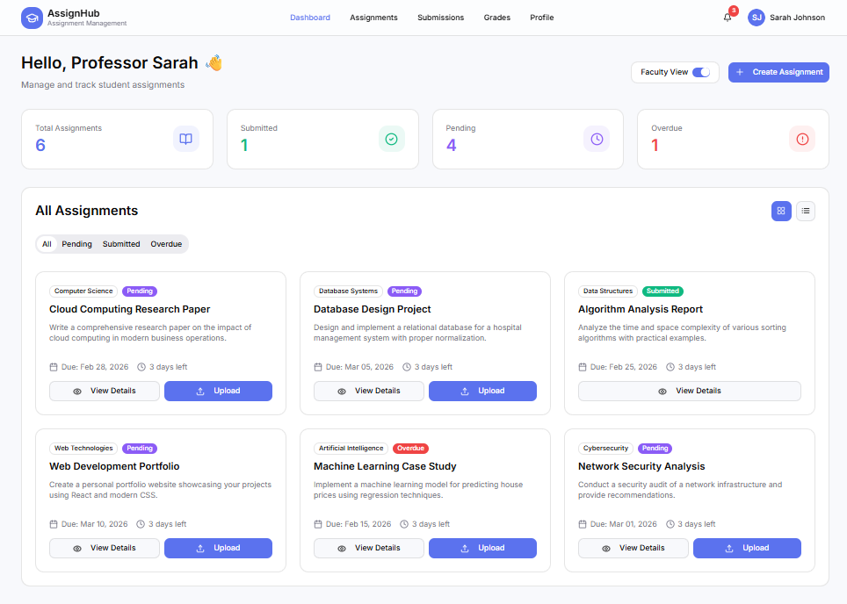

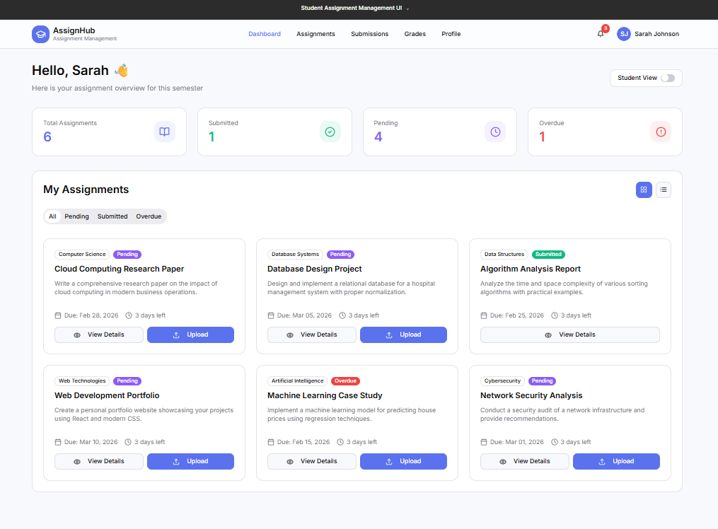

Web Portal Login and Role Management
The login module acts as the entry point of the system. It authenticates users and determines their role, such as student or faculty. Based on this role, the system dynamically renders the appropriate dashboard and restricts access to unauthorized features. This block ensures secure access control, session management, and structured navigation throughout the portal. It serves as the foundation for maintaining system integrity and protecting academic data.
Student Portal
The Student Portal is designed to provide access to assignments, quizzes, and coding assessments in a clear and organized manner. It is structured into three primary modules.
Assignment Upload Page
The Assignment Upload Page enables students to view assignment details, including descriptions, due dates, and submission status. Assignments are categorized as submitted, pending, or overdue, providing immediate visibility of academic responsibilities. Students can upload documents directly through a structured interface and review evaluated marks once grading is completed. The system records submission timestamps and enforces deadline validation to maintain fairness and accountability. This module ensures that students remain informed and aware of their academic progress.
Quiz Portal
The Quiz Portal displays all assigned quizzes along with their respective deadlines and scheduled times. Students can attempt quizzes within the defined time frame, and the system automatically records and stores their responses. After evaluation, scores become visible within the portal. This module provides a controlled assessment environment while maintaining clarity in navigation and result visibility. It ensures that quiz attempts are structured, timed, and securely evaluated.
Coding Platform
The Coding Platform supports programming-based assessments through an integrated development interface. Students can select programming languages such as Java, Python, C, or C++, write code in a structured editor, and execute it to view outputs. The platform includes visible problem statements, test case sections, a submission control, and a timer for timed assessments. Upon submission, the system evaluates code against predefined test cases and generates results. This module facilitates technical skill assessment while maintaining structured evaluation and transparency.
Faculty Portal
The Faculty Portal mirrors the student modules but incorporates management and evaluation capabilities. It enables instructors to create, monitor, and assess academic activities.
Assignment Portal
The Assignment Portal allows faculty members to create assignments, upload supporting materials, and define submission deadlines. Faculty can review submitted work, evaluate performance, assign marks, and monitor the status of submitted and non-submitted assignments. This block centralizes grading activities and enhances oversight of student engagement.
Quiz Page
Within the Quiz Page, faculty can create quizzes by uploading questions and configuring assessment parameters. After quiz completion, the portal provides access to individual student scores for evaluation and analysis. This block supports both structured question management and performance review, enabling efficient academic assessment.
Coding Platform
The Faculty Coding Platform allows instructors to create programming questions, define test cases, and configure evaluation criteria. Faculty members can review submitted code, validate outputs, and assign grades accordingly. This block ensures consistency in technical evaluation and enables instructors to maintain academic standards.
Database and Evaluation Engine
The Database and Evaluation Engine forms the core of the architecture. It stores user credentials, assignment details, quiz responses, coding submissions, and grades. It processes evaluation logic for quizzes and coding tasks and ensures data synchronization between student and faculty modules. This centralized engine maintains system reliability, data consistency, and scalability, enabling seamless interaction across all components.
Navigation Flow
The workflow of the portal follows a structured sequence. After login and role verification, users are directed to their respective dashboards. From there, they can navigate to assignments, quizzes, or coding modules. Each module interacts with the database and evaluation engine to retrieve or store data. Results and updates are then reflected back on the dashboard. This logical flow ensures clarity, prevents confusion, and maintains a consistent user experience across all sections.

4. Existing Solutions and Comparative Analysis
Various academic portals currently support assignment submission and online assessment. However, many platforms focus primarily on content sharing or require integration with external tools for quiz or coding functionalities. The proposed Assignment Portal distinguishes itself through unified integration, structured workflows, and a role-based architecture.
The following table presents a comparative analysis:

Feature Area | Google Classroom | Proposed LMS Assignment Portal
Overall Design Philosophy | Simple, lightweight classroom management tool | Full-featured academic performance & assignment ecosystem
Handwritten Assignment Upload | Upload images/PDF manually | Built-in camera capture, auto-crop, rotate, multi-page PDF merge, preview before submit
Quiz System | Uses Google Forms (external integration) | Built-in quiz engine with timer, instant grading, analytics dashboard
Interactive Coding Platform | No built-in coding editor | Integrated live coding editor with auto-grading & test cases
Progress Tracking | Basic grade overview | Visual dashboards, completion %, coding success rate, weekly activity summary
User Feedback | Teacher comments on submissions | Inline annotations, threaded discussion, structured feedback section
Deadline Management | Due date shown, email reminders | Countdown timers, in-app alerts (24hr & 1hr), overdue colour coding
Resubmission Handling | Allowed if teacher enables | Structured resubmission tracking with version history
Analytics for Students | Limited insights | Performance graphs, quiz trends, coding accuracy tracking
Mobile Optimization | Good mobile app | Fully responsive + coding-friendly mobile adaptation
Security Features | Google ecosystem security | Role-based access, encrypted file storage, optional 2FA
Gamification | Minimal | Progress bars, achievement badges (optional enhancement)
Customization | Limited UI customization | Custom themes, course-based layouts
Coding Assessment | Requires external platforms | Fully integrated system
Support System | Basic help section | In-app support form + FAQ + technical issue reporting

Unlike fragmented systems that require multiple platforms, the proposed portal consolidates all academic activities into a single environment. It enhances transparency through status categorization, improves evaluation efficiency through a centralized engine, and maintains usability through a consistent design language.

5. Conclusion
The Assignment Portal represents a comprehensive academic management solution designed to enhance clarity, efficiency, and accountability within educational institutions. By integrating assignment submission, quiz administration, and coding evaluation into a unified architecture, the system eliminates fragmentation and improves academic workflow organization.
The structured architecture ensures secure role-based access, centralized evaluation, and seamless navigation across modules. Compared to existing solutions, the portal offers improved integration, enhanced transparency, and responsive design aligned with modern usability standards.
This design establishes a scalable and reliable framework for digital academic management, making it suitable for institutional adoption and long-term development.
Figma link:
https://www.figma.com/make/ZJyeZa0zudGwcvo2ijBIiH/Student-Assignment-Management-UI?p=f&t=UFVNmxDoow7VwbKn-0&fullscreen=1

